**GAME DESIGN DOCUMENT (GDD)**

**CCTV INVASION**



**Created By :**

Sophi Nuraeni 2101705574

Pramadito Rafiaqil 2101705542

Lukius Jonathan 2101705624

Jevon Wirjono 2101705486

**BINUS UNIVERSITY**

**2018/2019**

# **DAFTAR ISI**

**DAFTAR ISI** 2

**BAB 1 TITLE PAGE** 3

1.1 Game Name 4

**BAB 2 GAME OVERVIEW** 4

2.1 Game Concept 4

2.2 Genre 4

2.3 Targer Audience 4

2.4 Game Flow Sumary 4

2.5 Look and Feel 4

**BAB 3 GAMEPLAY AND MECHANICS** 5

3.1 Gameplay 5

3.1.1 Game Progression 5

3.1.2 Mission and Challenge Structure 5

3.1.3 Puzzle Structure 5

3.1.4 Objectives 5

3.2 Mechanics 5

3.2.1 Physics 5

3.2.2 Movement in the Game 5

3.2.3 Objects 5

3.2.4 Actions 5

3.2.5 Combat 5

3.2.6 Economy 5

3.2.7 Screen Flow 6

3.3 Replaying and Saving 6

**BAB 4 STORY SETTING ANDCHARACTER** 6

4.1 Story and Narative 6

4.2 Game World 7

4.2.1 General Look and Feel of World 7

4.3 Characters 7

**BAB 5 LEVELS** 7

5.1 Levels (penjelasan level lebih ke bagaimana pelevelan dalam game ini dibuat) 7

5.2 Training Levels 7

**BAB 6 INTERFACE** 7

**6.1 Visual System** 7

6.2 Control System 7

6.3Audio, Music and Sound Effect 8

6.4 Help System 8

**BAB 7 AI** 9

7.1 Opponent and Enemy AI 9

7.2 Support AI 9

**BAB 8 TECHNICAL** 10

8.1 Target Hardware 10

8.2 Development Hardware and Software 10

8.3 Network Requirements 10

**BAB 9** 10

# **BAB 1**

**TITLE PAGE**

## **1.1 Game Name**

**CCTV Invasion**, the name of the game is taken based on the city where it has been abandoned because cctv installed in every corner of the city can carry out attacks on everyone.

# **BAB 2**

**GAME OVERVIEW**

## **2.1 Game Concept**

CCTV Invasion is an adventure fantasy 3D game which the character is a person who want to survive from this nightmare place and bring peaceful to him because he tired of running. He must survive from all the obstacle that hold his/her way to safe place.

The purpose of this character is to safe from all CCTV that have radius to shoot him, he must find a hard and rough way to get safe place, in this game he can choose weapon and find weapon that he want to use to defeat all the obstacle and enemy in his way. The character will reach certain point where the character can get a powerful weapon to increase his opportunity to get a safe place safely. In this game also the character need to be careful and see all over around because the CCTV is hidden and we need focus in this game.

## **2.2 Genre**

Adventure-Fantasy-Survival-FPS

* Adventure because the player assumes the role of protagonist in an interactive story driven by exploration and puzzle-solving.
* Fantasy because there is an influence of magic and myth in the story of the game that used imagination that how the future look like when people don’t stay at that place for a long time.
* Survival Game is because we as a character must go to safe place and survive from all over the obstacle in this game.
* FPS game because this game is using First Person Shooter Perspective that we used all over the game.

## **2.3 Targer Audience**

The target audience for this game is teenager until adult, also people who attracted to action-fps genre game. It is highly recommended that players have over the age of 13 years. violence also occurs in this game, so it is strongly recommended that guidance from parents.

## **2.4 Game Flow Sumary**

In this game player need to go through the map to complete the game. Character will have nothing in first respawn, and need to find gun, gate, open new map, etc. In this game player will survive alone and no one can help him, except the character itself.

As he fight the CCTV the player will open more map, because he can move freely without CCTV in the area, but CCTV only can be shutdown using gun that he find in his journety to the safe place. If the player lose his life, he need to restart the game from the beginning he start that he have nothing, so in this game we need to be careful of the powerful CCTV Invasion.

## **2.5 Look and Feel**

This game design and gameplay were designed from a game called WatchDogs (from the CCTV) but different in game, in WatchDogs game we can see the CCTV can see anything from it sights and have big impact in that game, also in this game we want have the same objectives that CCTV have big impact in this game and make the hardest obstacle. In this game character feel tiny and hopeless without gun to kill the CCTV and all the CCTV want kill the character.

The theme of the game is the future city that no one lived again, this city has abandoned almost for a hundred years and make this city feels not good to live in.

# **BAB 3**

**GAMEPLAY AND MECHANICS**

## **3.1 Gameplay**

### **3.1.1 Game Progression**

At the beginning of the game, the player is given the starter weapon and starting consumable

### **3.1.2 Mission and Challenge Structure**

The player will be encountering various enemies throughout the stage which is CCTV placed around the map. Encountered enemies will Shoot player in their line of sight

### **3.1.3 Puzzle Structure**

In this section, the player will have to find other weapon hidden throughout the map. Upon finding the weapon, the player will be rewarded with new powerful tools.

### **3.1.4 Objectives**

When the player is in the stage, the player must find their way to the end area through combat and exploration

## **3.2 Mechanics**

### **3.2.1 Physics**

Gravity exists, and will affect player’s drop speed, while player also get damaged from falling from high altitude.

### **3.2.2 Movement in the Game**

Player is able to move through the 3d space like a normal person, which can walk, run and jump. Player can also sprint to move faster for avoid damage from various hazards.

### **3.2.3 Objects**

Players automatically pick up objects such as weapons and abilities on touching said object. Furthermore, the player can organize the weapons and abilities through the inventory menu.

### **3.2.4 Actions**

Players can pick up objects such as weapons on hovering said object. Furthermore, the player can organize the weapons through the inventory menu.

### **3.2.5 Combat**

The player is given a fast moves to be used in combat against hostile NPCs

### **3.2.6 Economy**

In this game, ammo is obtained from ground. The player can gain more ammo that they can find through out the map.

### **3.2.7 Screen Flow**

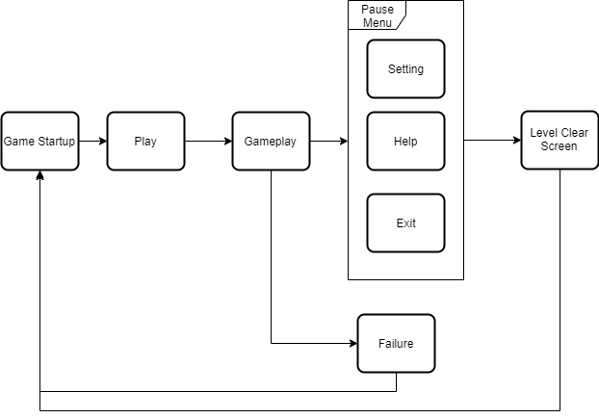

## **3.3 Replaying and Saving**

Saving in-game is automatically done to prevent save scumming. If the player exits and re-enters the game, then the player will be transported to the last checkpoint.

# **BAB 4**

**STORY, SETTING AND CHARACTER**

## **4.1 Story and Narative**

1. Backstory

At some time in the Future, the humankind has gone extinct in the surface, Many places in the world was desolated. Machine, the relic of the old world has been programmed to survive on its own and become more advanced than the human itself. All the machine in the world has gone rogue and exterminated most of the people in the world.All of the surviving people gone underground and has been living there since.

Retno Sugidja Pranoto is one of the people who live in the underground. He is a scavenger to search for resources in the surface. While scavenging he also build a safe house for his secret belongings. Retno is an alcoholic and often beat his wife, until one day a fight happen and Retno accidentally killed his wife. The Underground people lay a punishment to Retno by kicking him out to the surface.

After Retno was kicked outside, He is now realized that he is in grave danger of the Automatron(CCTV Hunter). Retno must reach his way to his safe house so he can get supplies and last one more day.

1. Plot Elements

Machine Apocalypse

1. Game Progression

* Open World advancement
* Acquiring new weapon
* Safe Room save point

## **4.2 Game World**

### **4.2.1 General Look and Feel of World**

The setting take place in one of the old abandoned city in the surface of the world.

## **4.3 Characters**

The Character is Retno Sugidja Pranoto a scavenger of the underground in his mid 40. Who lives with his wife and his bedridden mother. Retno is an alcoholic and hated by the underground community. He often put supply that he steal and place it in his safe house.

# **BAB 5**

**LEVELS**

## **5.1 Levels (penjelasan level lebih ke bagaimana pelevelan dalam game ini dibuat)**

In this Level the player needs to go to the safehouse and avoid automatron(CCTV Hunter) which the character has been built to recover the supply.Level can be choosed from easy , normal ,hard.

1. General Description

It will feel like an apocalyptic city, the city is small and took place like in the suburban region.

1. Physical Characteristics

Gloomy atmosphere, cloudy.

## **5.2 Training Levels**

There will be no training level. The player can try out the basics from level 1.

# **BAB 6**

**INTERFACE**

## **6.1 Visual System**

Camera View : first person perspective that makes the player invisible because he is behind the weapon.

HUD : HP, Switch Weapon, bullets available, control system information, menu (can show/hide)

## **6.2 Control System**

W, S, A, D : Move

Shift : Run

Space : Jump

LMB : Fire

RMB : Zoom

Scrolling / Q,E : Change Weapon

C : Crouch / Stand

X : Switch shooting mode [pistol, *AR, shotgun]

V : switchto sub weapon and back [*AR]

Z : switch witch ammo type [*GL on *AR and crossbow]

R : reload weapon

J : drop weapon

F : pickup item

K / L : show / hide cursor

Escape / P “ show / hide menu

------------------------------------------------------------------------

*AR : Assault Rifle

*GL : Grenade Launcher

## **Audio, Music and Sound Effect**

1. **Audio**

Interaction in this game does not use audio because here the interaction is only indicated by an icon that appears or an icon that changes, such as when the interaction will take a weapon, a hand icon appears which means items that can be taken.

1. **Music**

This game has a deserted city theme that has been abandoned and uninhabited. so the background music used in this game is a calm sound that shows an uninhabited city that is the sound of nature such as the sound of the wind, the sound of tree leaves rubbing against, the sound of water and the sound of gripping music in certain circumstances.

1. **Sound Effect**

The sound effect in this game is used when players are take an action like

* when taking an item there is a sound effect of the item being taken
* when changing weapons there is a sound effect of changing weapons
* when shooting use pistol/shotgun there is a shot sound effect
* when destroying the object there will be a sound effect of the broken object
* when walking there are foot stepping sound effect
* when jumping there is a sound effect landing on the ground
* when there is little life left there will be a sound effect of rapid heartbeat

## **6.4 Help System**

The help system is used in this game is by press f1 for the help of the control system information. this information will appear in text form and this can be raised at any time while playing the game.

# **BAB 7**

**ARTIFICIAL INTELLIGENCE**

## **7.1 Opponent and Enemy AI**

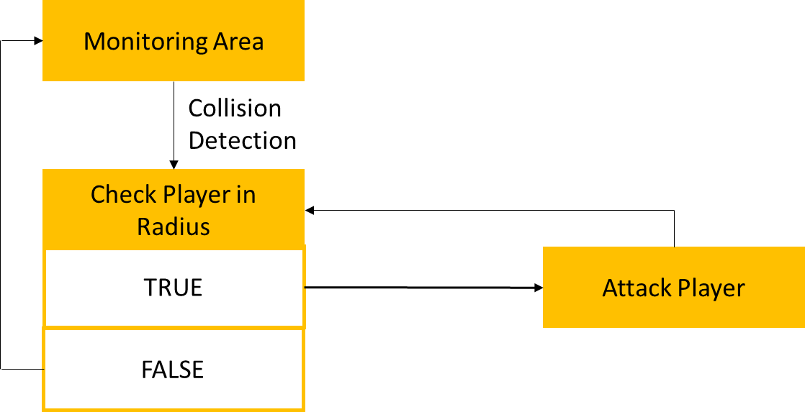

Behavior and Strategi

CCTV monitors the area by rotating to the right and left, if the player is in the cctv surveillance radius then the cctv will attack by shooting the player. player is recommended to stay away from cctv surveillance radius and if you want to attack can be shot outside the radius so that the hp player remains safe.

## **7.2 Support AI**

Collision Detection

* Player and Enemy

Using Circle Collision as collision detection which is a transparent circle in a player and enemy. With Circle Collision, it will check the distance between the two center points of the circle. If yes, then there is no collision and if it is not, then a collision has occurred. So if a collision occurs means the player is in the cctv radius so that the cctv will continue to attack the player

* Wall and Item

Using Bounding Box as collision detection which is a transparent box. Ensure there is no distance between the two boxes, so that when the two boxes touch, a collision has occurred. There is no distance like a circle. So that when used for the wall player it will not be able to pass through the wall while for items when the player hits collision items, the player is considered to be dealing with items and algorithmically, as a detector that items can be retrieved if the player is about collision items.

# **BAB 8**

**TECHNICAL**

## **8.1 Target Hardware**

Target Hardware :

* OS: Windows 7 or newer
* Processor: Dual core from Intel or AMD at 2.8 GHz
* Memory: 4 GB RAM
* Graphics: nVidia GeForce 9600GT, ATI/AMD Radeon HD2600/3600
* DirectX: Version 9.0c
* Network: None
* Storage: 4 GB available space
* Sound Card: DirectX Compatible

Recomended Hardware :

* OS: Windows 10 64-bit
* Processor: Intel Core i7-3770 or AMD Ryzen 5 1600
* RAM: 8 GB RAM
* Graphics: GeForce GTX 970 or Radeon R9 fury
* DirectX: Version 11
* Storage: 25 GB available space

## **8.2 Development Hardware and Software**

Development Hardware Specification:

* Game Engine: Unity 2018.3.0f2
* OS: Windows 10
* Processor: Intel - Core i7-7700HQ CPU @ 2.8 GHz (8 CPUS), ~2.8GHz
* Graphics : GeForce GTX 1050 Graphics Cards
* Storage: SSD 128 GB and HDD 1 TB

Development Software:

* Adobe Illustrator CC 2019
* Adobe Photoshop CC 2019
* Unreal Engine 4 or Unity

## **8.3 Network Requirements**

Network: None

We don’t need network requirements because this is not an online games, this is a offline games so we don’t need any networking to play with.

# **BAB 9**

**GAME ART**

**Items**

**Character**

**Game Maps**

**Settings Menu**

